Comparing Serial Interfaces
We've looked at several different interfaces in this course. Now we are ready to review them and compare their relative advantages and disadvantages. Its important to remember that there is no 'best' interface, they all take different approaches to the problem of facilitating communication between devices. You should be try and consider all the options when deciding what kind of interface or interfaces to implement; including the option that you may implement multiple interfaces simultaneously, all controlled by your microcontroller.
Asynchronous Serial
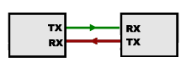
This is the interface we use when communicating between the Arduino and the computer. The advantages are that it requires only two lines (though they are hidden inside the USB cable for our application) and that the devices on either end do not need to be tightly synchronized. The low level software driving this interface is comparatively simple. The disadvantages are that is requires extra hardware in the form of a Universal Asynchronous Receive and Transmit (UART) which buffers the data from the devices talking at different speeds. It also has the disadvantage that it is NOT a bus, we can only connect two devices with this approach. Lastly, it is the slowest of the interfaces we will compare.

I2C Bus
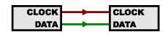
This is the interface we used with the 9DoF and the OLED display. The advantages to this bus are that it uses a very simple two wire interface, meaning the wiring remains very simple as we scale up the number of devices on the bus. It doesn’t require any additional special hardware. This bus is faster than asynchronous, but not as fast as SPI. The disadvantages are in the added software complexity of addresses. Also, it can occasionally be complicated if you want to add multiple instances of a device that is hard-wired to a specific address.
SPI Bus
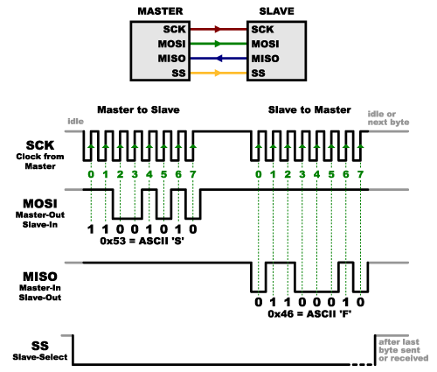
This is the interface we used with the SD Card and BME280. The advantage of this bus is that it is very fast, and the software to operate is is simpler than I2C. It doesn’t require any additional special hardware. The disadvantage is that each device requires a dedicated CS line, so adding many devices can be more difficult to wire.

